Course Code: CSA1557

Course Name: Cloud Computing and Big Data Analytics

R.Pranusha 192111023

5) Create a simple cloud software application for Mark Sheet Processing System using any Cloud Service Provider to demonstrate SaaS include the necessary fields such as name of the student, Reg no of the student, Subjects , Marks, Average, percentage, rank, overall performance etc.

AIMS:

To create a simple cloud software application for Mark Sheet Processing System using any Cloud Service Provider to demonstrate SaaS.

PROCEDURE:

Step1: Go to zoho.com.

Step 2: Log into the zoho.com.

Step 3: Select one application step.

Step4: Enter application name as GradeHub.

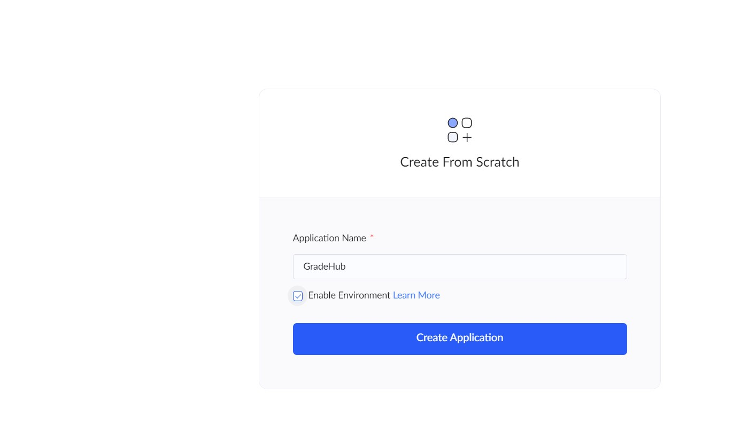

Step 5: Created new application as GradeHub.

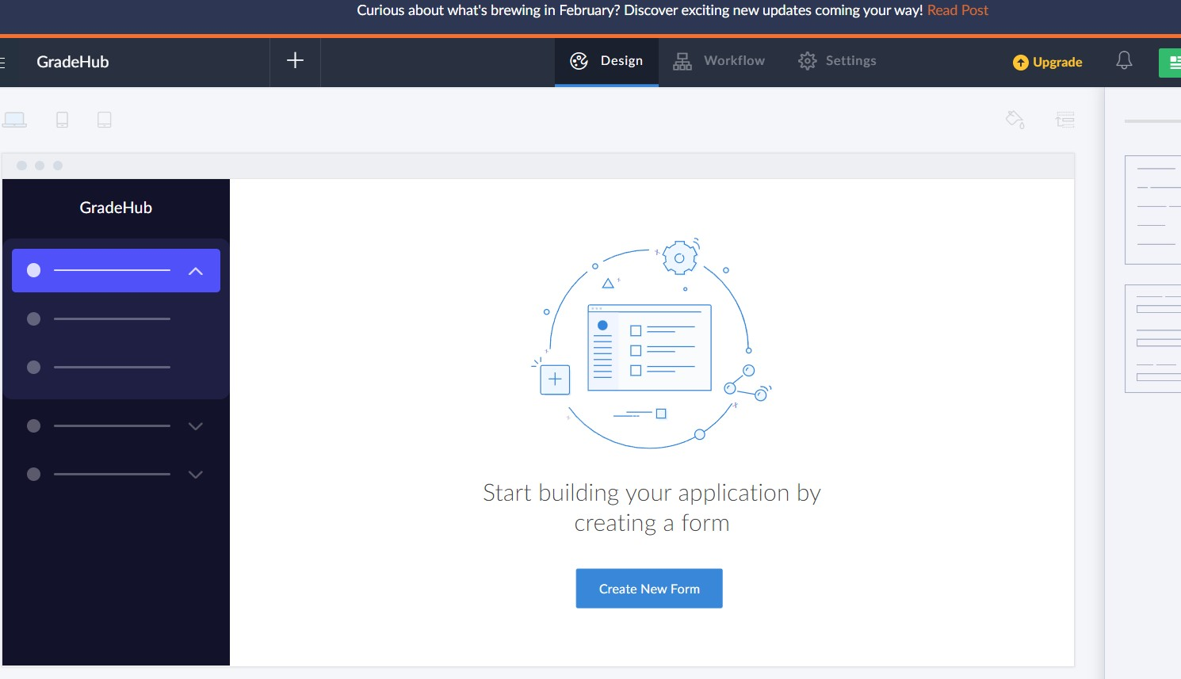

STEP 6: Select from Stratch and Create form as SEM1.

STEP 7: The form has been created as Book

Choose the fields.

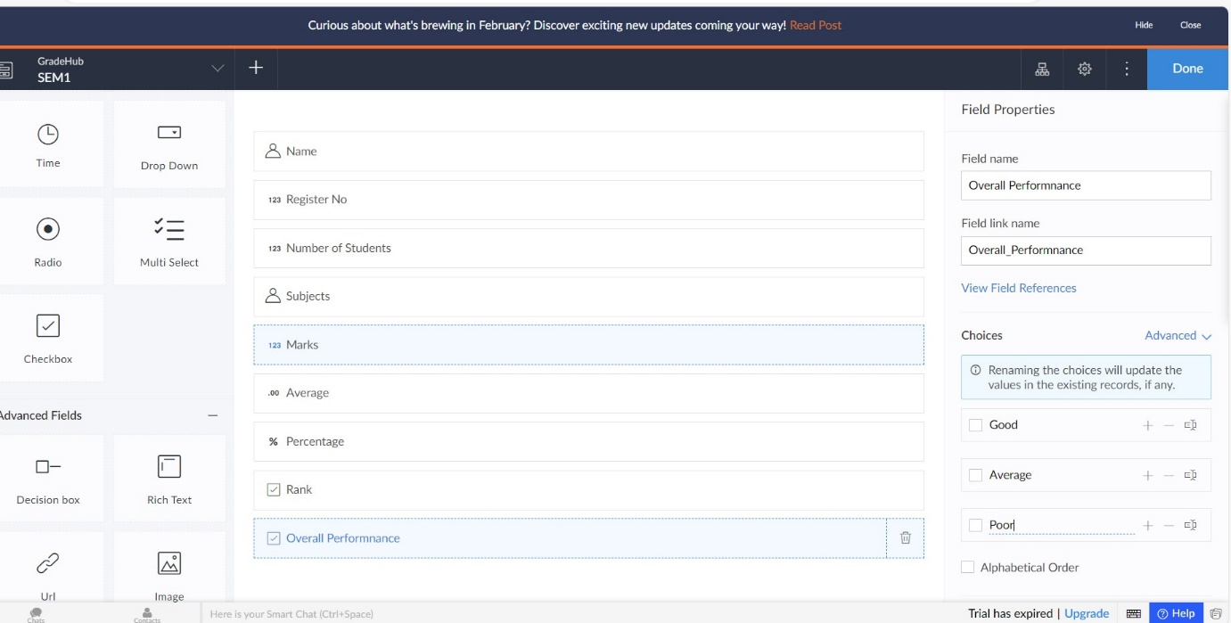

STEP 8: Click Access Development Live

STEP 9: Enter the details of the SEM1.

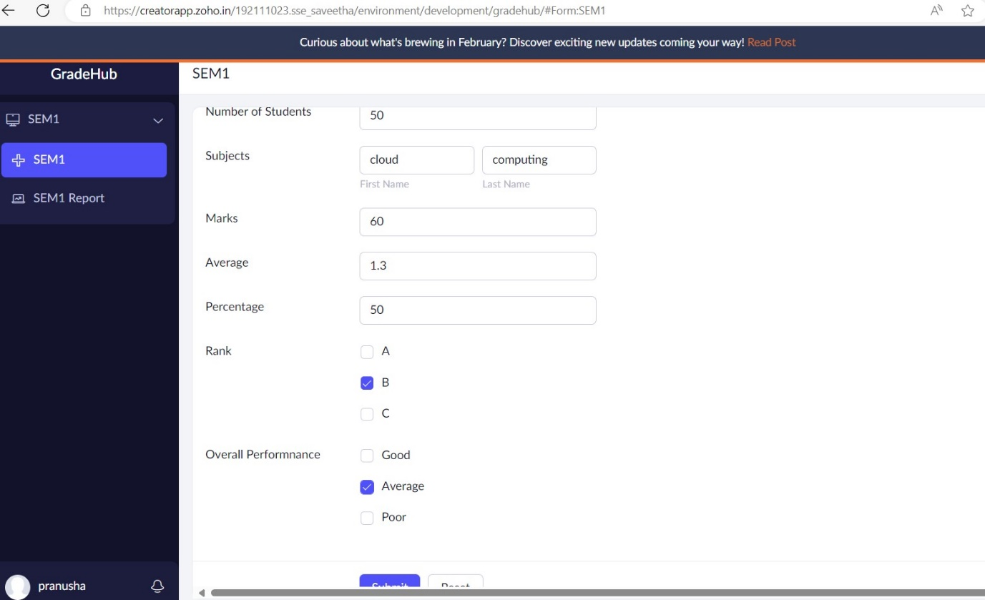

STEP 10: The report has been entered in the SEM1 report.

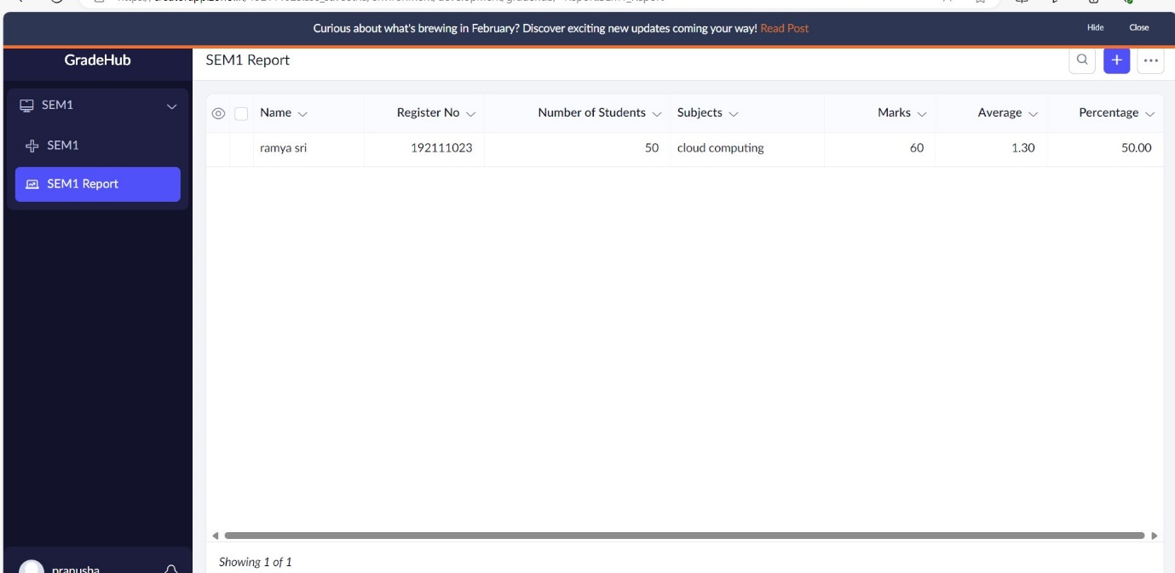

STEP 11: Select from Stratch and Create form as Student details.

STEP 12: The form has been created as

Choose the fields.

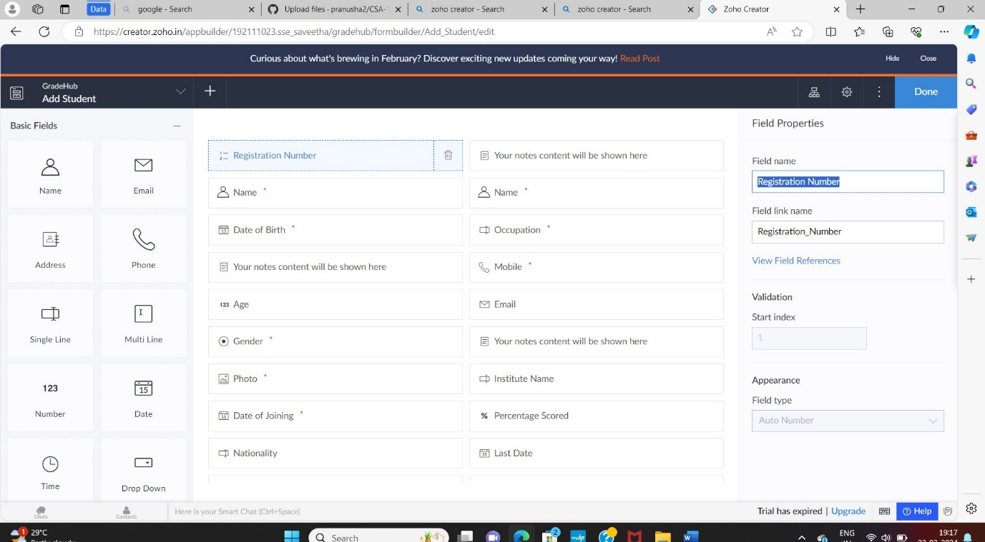

STEP 13: Click Access Development Live

STEP 14: Enter the details of the Students.

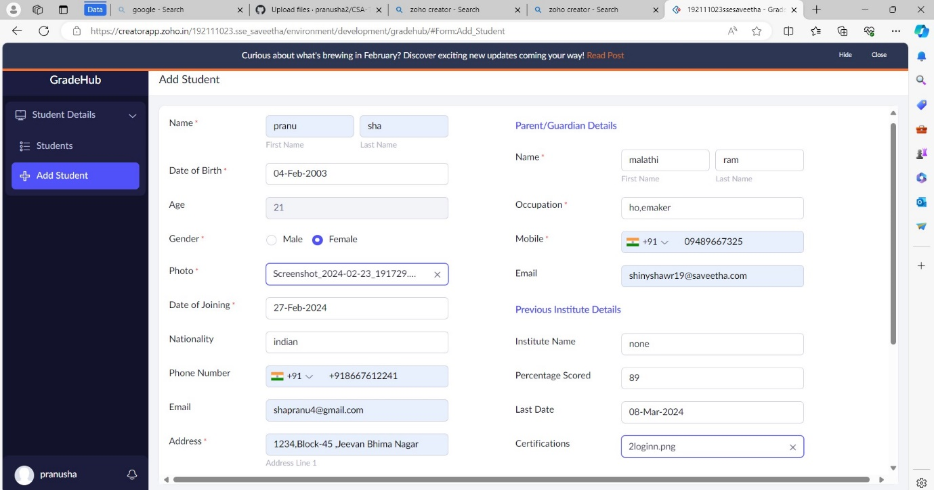

STEP 15: The report has been entered in the Student report.

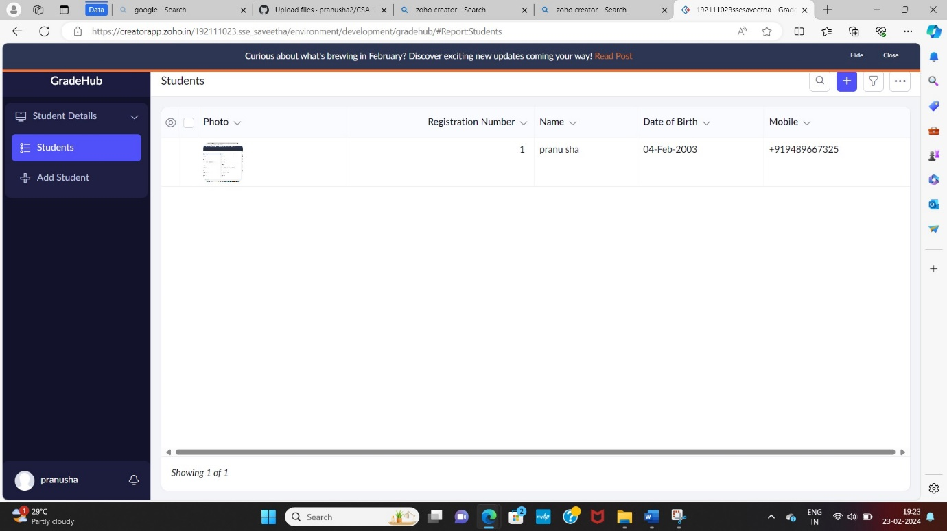

STEP 16: Select from Stratch and Create form as Feedback.

STEP 17: The form has been created as Feedback

Choose the fields.

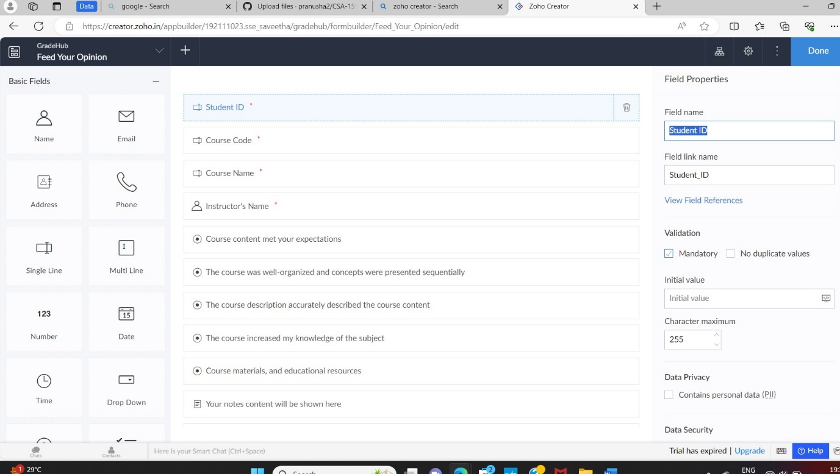

STEP 18: Click Access Development Live

STEP 19: Enter the details of the Feedback.

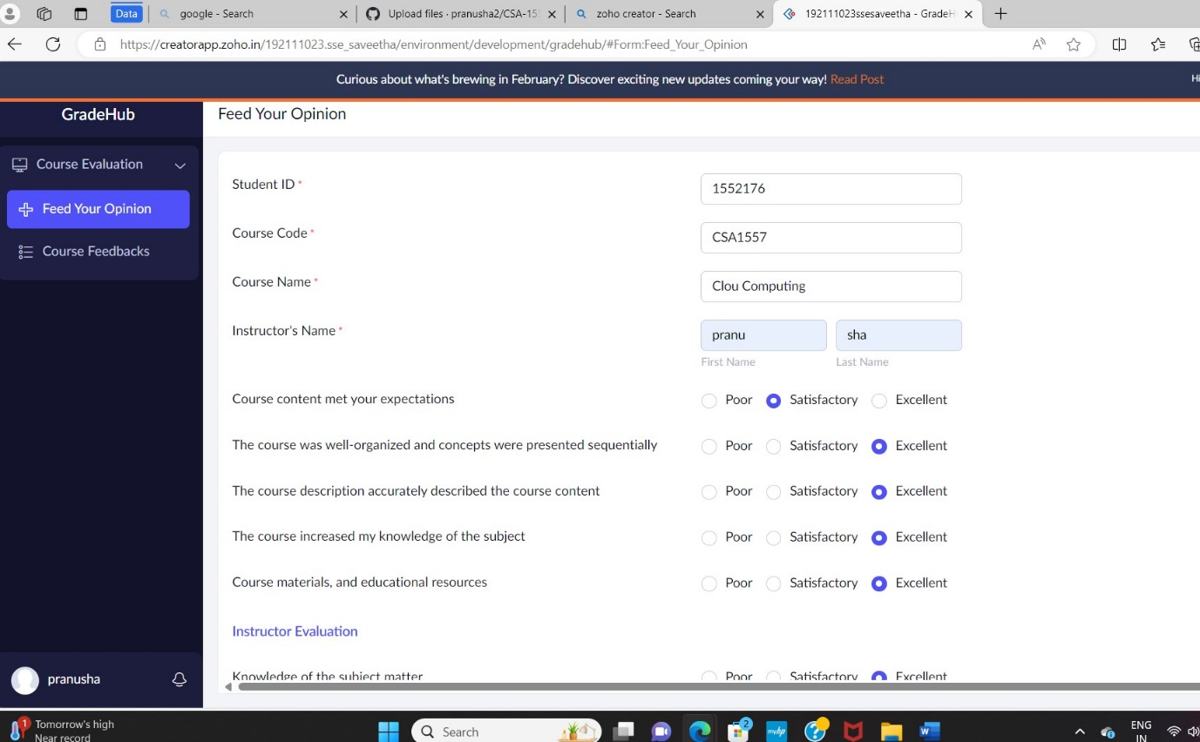

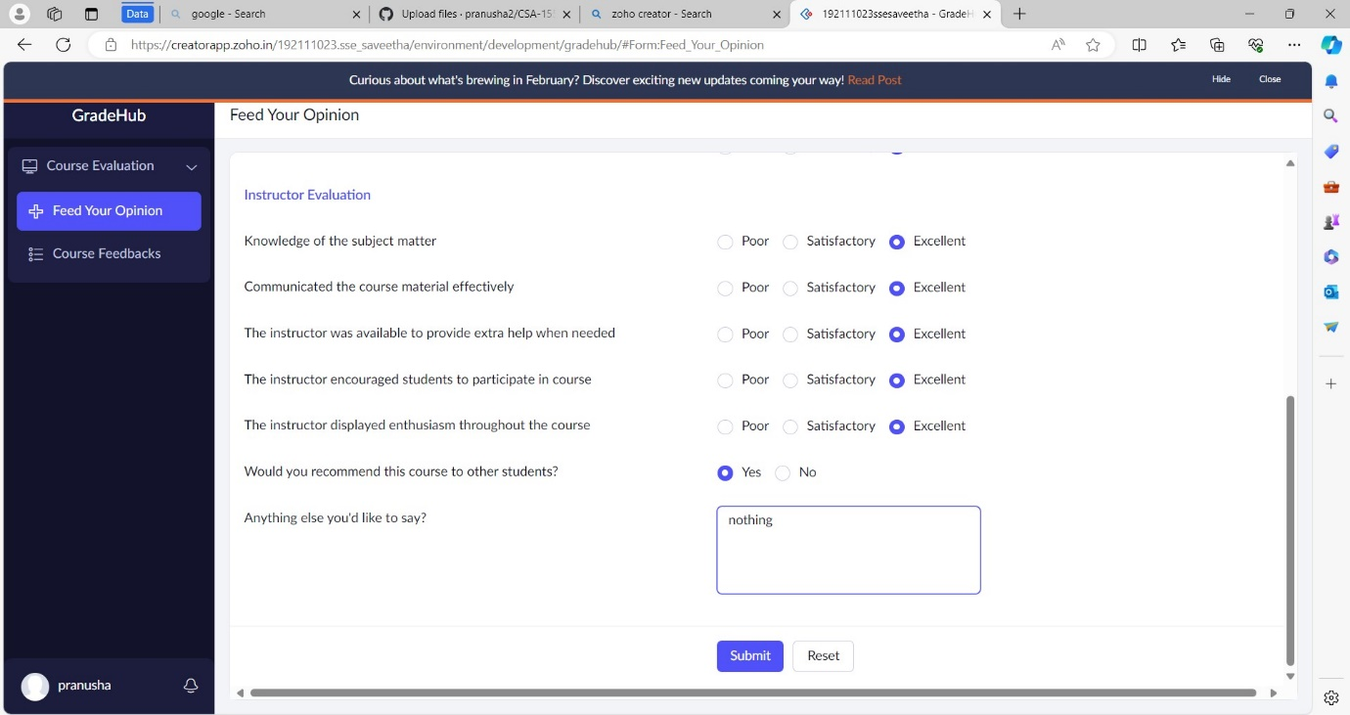STEP 20: The report has been entered in the Feedback report.

